Make (C/C++)
# Source: AI Source: Provided by: [Data Path: Persons Table -> ID Column: 1, Name_En Column: Motasem Essam] -> From: [ChatGPT] on [1/26/2026]
Make is a build automation tool mainly used in C and C++ projects to compile code and manage dependencies efficiently using a configuration file called a Makefile.

⚙️ What Make Does:
# Source: AI Source: Provided by: [Data Path: Persons Table -> ID Column: 1, Name_En Column: Motasem Essam] -> From: [ChatGPT] on [1/26/2026]
● Compiles source files into object files automatically
● Links object files to create executables
● Tracks dependencies between files
● Rebuilds only modified parts of the project
● Automates repetitive build tasks

📄 Makefile
# Source: AI Source: Provided by: [Data Path: Persons Table -> ID Column: 1, Name_En Column: Motasem Essam] -> From: [ChatGPT] on [1/26/2026]
Makefile is a text file used by Make that defines how to build a program, including compilation rules, dependencies, and commands.
👉 Think of it like a recipe: it tells the system what to build and how to build it step by step.

⚙️ What a Makefile Contains:
# Source: AI Source: Provided by: [Data Path: Persons Table -> ID Column: 1, Name_En Column: Motasem Essam] -> From: [ChatGPT] on [1/26/2026]
● Targets → what you want to create (e.g., executable)
● Dependencies → files needed to build the target
● Commands → instructions to build (compile/link)

📦 Basic Structure
# Source: AI Source: Provided by: [Data Path: Persons Table -> ID Column: 1, Name_En Column: Motasem Essam] -> From: [ChatGPT] on [1/26/2026]
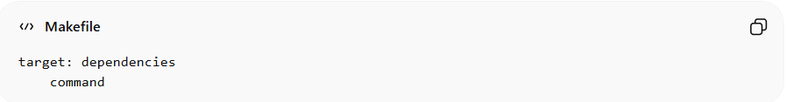
target: dependencies
command
👉 Important: The command must start with a TAB, not spaces.

✅ Example
# Source: AI Source: Provided by: [Data Path: Persons Table -> ID Column: 1, Name_En Column: Motasem Essam] -> From: [ChatGPT] on [1/26/2026]
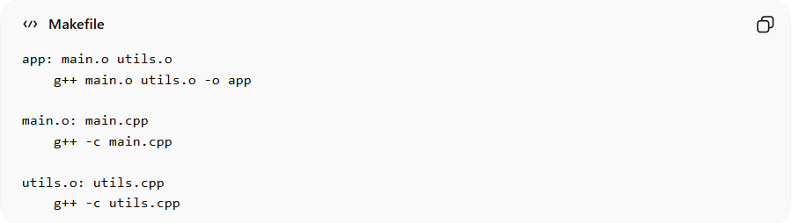
app: main.o utils.o
g++ main.o utils.o -o app

main.o: main.cpp
g++ -c main.cpp

utils.o: utils.cpp
g++ -c utils.cpp

🧠 How It Works
# Source: AI Source: Provided by: [Data Path: Persons Table -> ID Column: 1, Name_En Column: Motasem Essam] -> From: [ChatGPT] on [1/26/2026]
When you run:
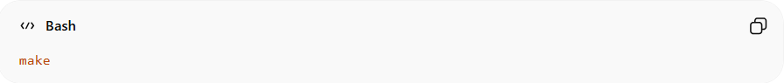
make
Make will:
- Look for a Makefile
- Check timestamps of files
- Rebuild only what changed

⚡ Why Use Makefile?
# Source: AI Source: Provided by: [Data Path: Persons Table -> ID Column: 1, Name_En Column: Motasem Essam] -> From: [ChatGPT] on [1/26/2026]
• Automates compilation process
• Handles dependencies automatically
• Saves time in large projects
• Keeps build process organized

⚠️ Important Notes
# Source: AI Source: Provided by: [Data Path: Persons Table -> ID Column: 1, Name_En Column: Motasem Essam] -> From: [ChatGPT] on [1/26/2026]
• Must use TAB before commands
• File name should be:
- Makefile OR makefile
• Works mainly with C/C++ projects

🧠 Quick Summary
# Source: AI Source: Provided by: [Data Path: Persons Table -> ID Column: 1, Name_En Column: Motasem Essam] -> From: [ChatGPT] on [1/26/2026]
Makefile = Instructions for Make
✔ Defines build steps
✔ Tracks dependencies
✔ Automates compilation

✅ Why Use Make?
# Source: AI Source: Provided by: [Data Path: Persons Table -> ID Column: 1, Name_En Column: Motasem Essam] -> From: [ChatGPT] on [1/26/2026]
Feature Description
⚡ Faster Builds Only recompiles changed files
🔗 Dependency Management Automatically tracks file relationships
🧠 Automation Reduces manual compilation work
📦 Scalable Handles large multi-file projects
💻 Standard Tool Widely used in Linux and C/C++ environments

📦 Example Makefile
# Source: AI Source: Provided by: [Data Path: Persons Table -> ID Column: 1, Name_En Column: Motasem Essam] -> From: [ChatGPT] on [1/26/2026]
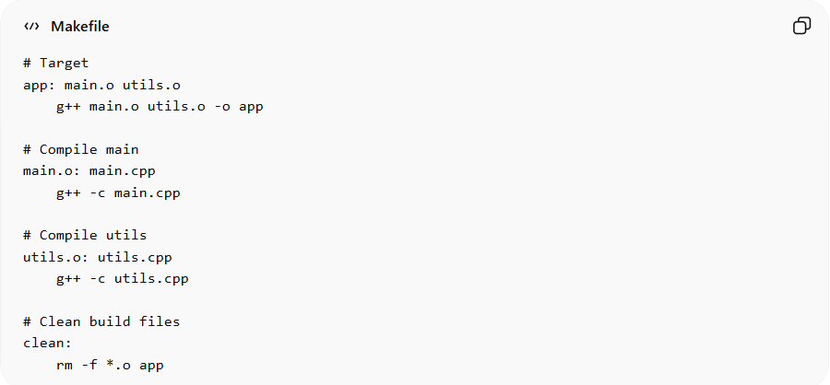
# Target
app: main.o utils.o
g++ main.o utils.o -o app

# Compile main
main.o: main.cpp
g++ -c main.cpp

# Compile utils
utils.o: utils.cpp
g++ -c utils.cpp

# Clean build files
clean:
rm -f *.o app

▶️ Common Make Commands
# Source: AI Source: Provided by: [Data Path: Persons Table -> ID Column: 1, Name_En Column: Motasem Essam] -> From: [ChatGPT] on [1/26/2026]
▶️ Build the project:
make
🔁 Rebuild everything:
make clean
make
🧹 Clean compiled files:
make clean
🎯 Build specific target:
make app

📁 How Make Works
# Source: AI Source: Provided by: [Data Path: Persons Table -> ID Column: 1, Name_En Column: Motasem Essam] -> From: [ChatGPT] on [1/26/2026]
Make reads the Makefile and:
- Checks file timestamps
- Detects what changed
- Rebuilds only necessary parts
👉 This makes builds fast and efficient

⚠️ Limitations of Make
# Source: AI Source: Provided by: [Data Path: Persons Table -> ID Column: 1, Name_En Column: Motasem Essam] -> From: [ChatGPT] on [1/26/2026]
• Makefiles can become complex in large projects
• Syntax is hard for beginners
• Not cross-platform friendly without adjustments
• Often replaced by tools like CMake for modern projects

🧠 Make vs Manual Compilation
# Source: AI Source: Provided by: [Data Path: Persons Table -> ID Column: 1, Name_En Column: Motasem Essam] -> From: [ChatGPT] on [1/26/2026]
Feature Manual Build Make
Automation ❌ No ✅ Yes
Dependency Tracking ❌ No ✅ Yes
Efficiency ❌ Low ✅ High
Scalability ❌ Poor ✅ Excellent

